Ideation Phase
Empathize & Discover

Date | 3rd October 2026
Team ID | SWTID-2026-3114
Project Name | Implement Client Script & UI Policy (Incident)
Maximum Marks | 4 Marks

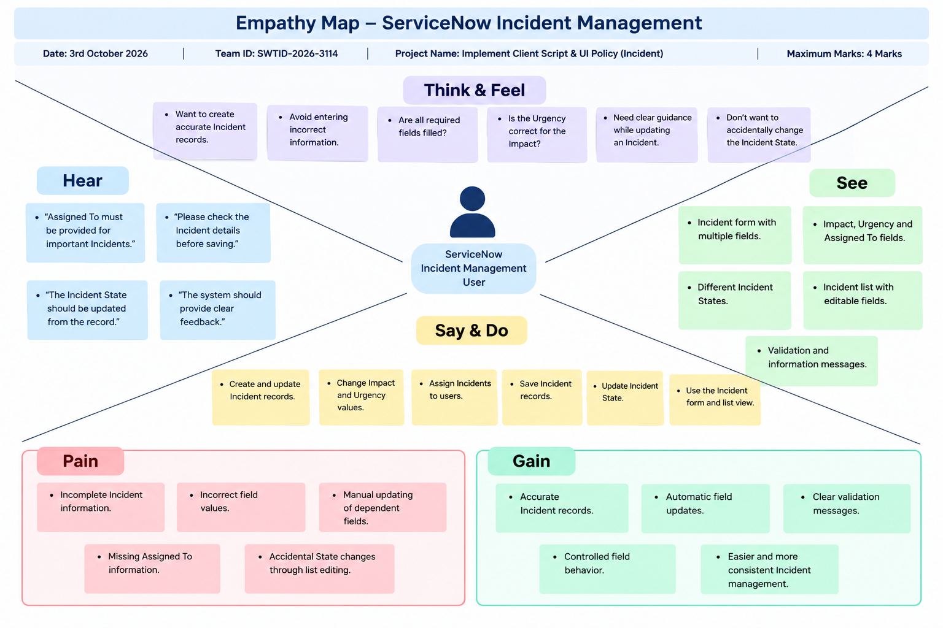
Empathy Map – ServiceNow Incident Management

User: ServiceNow Incident Management User

